PROJECT GREENHOUSE-

USER MANUAL (Version 1.0)

Prepared by - Atharv Shylesh Dave

Date - 20th July, 2025

TABLE OF CONTENTS-

1. Introduction
2. System Overview
3. Hardware Requirements
4. The Circuit
5. Software Setup
6. Code Overview
7. Operating Instructions
8. Safety Guidelines
9. Troubleshooting

CHAPTER 1 - INTRODUCTION:

This system monitors two temperature points using DS18B20 sensors and activates a 4-relay module based on temperature thresholds. It is built on an Arduino Uno microcontroller and suitable for basic HVAC or safety alert systems.

Furthermore, the relay module operates on 4 devices: 2 exhaust fans and 2 mist sprays. The entirety of the circuit is programmed in order to operate based on the specified requirements of temperatures.

This project primarily focuses on the control of surplus temperature, with a possibility of further enhancement for future purposes.

CHAPTER 2 – SYSTEM OVERVIEW:

* Microcontroller – Arduino UNO
* Sensors - DS18B20 Temperature Sensor
* Output Control - 4 Relay module:

Pin 1: Inlet Exhaust

Pin 2: Outlet Exhaust

Pin 3,4 : Mist nozzles

* Function –

Step 1: Takes in input from 2 temperature sensors

Step 2: Averages the temperatures out

Step 3: If the average exceeds 28, activates the relay

CHAPTER 3 - HARDWARE REQUIREMENTS:

* DS18B20 Temperature Sensor - 2
* 4-Relay Module – 1
* Mist Spray Nozzles -2
* Exhaust Fans – 2
* 5V external power supply – 1
* 4.7 k ohm Resistor- 2
* Breadboard/ Copper-clad Board - 1
* Jumper wires – Male-to-Female: 6

Male-to-Male: 6 (for the case of breadboard)

* Jumper shunt (For the extra VCC pins of the module)

CHAPTER 4 – THE CIRCUIT:

**DS18B20 Sensor 1 (Digital)**

* **VCC** → External Power Supply (5V)
* **GND** → Arduino GND
* **DATA** → Arduino Pin 8
* **Pull-up resistor**: 4.7kΩ between DATA and VCC

**DS18B20 Sensor 1 (Digital)**

* **VCC** → External Power Supply (5V)
* **GND** → Arduino GND
* **DATA** → Arduino Pin 9
* **Pull-up resistor**: 4.7kΩ between DATA and VCC

**Relay Module**

* **IN** → Relay Pin 1- Arduino Digital Pin 2
* Relay Pin 2- Arduino Digital Pin 3
* Relay Pin 3- Arduino Digital Pin 4
* Relay Pin 4- Arduino Digital Pin 5
* **VCC** → Arduino 5V
* **GND** → Arduino GND

**Relay Module (OUTPUT) –**

* Relay Pin 1 → Inlet Exhaust
* Relay Pin 2 → Outlet Exhaust
* Relay Pin 3 → Mist Spray Nozzle
* Relay Pin 4 → Mist Spray Nozzle
* JD-VCC Pin 1 and 2 → Covered by Jumper Shunt/Jumper Cap

**Circuit Diagram –**

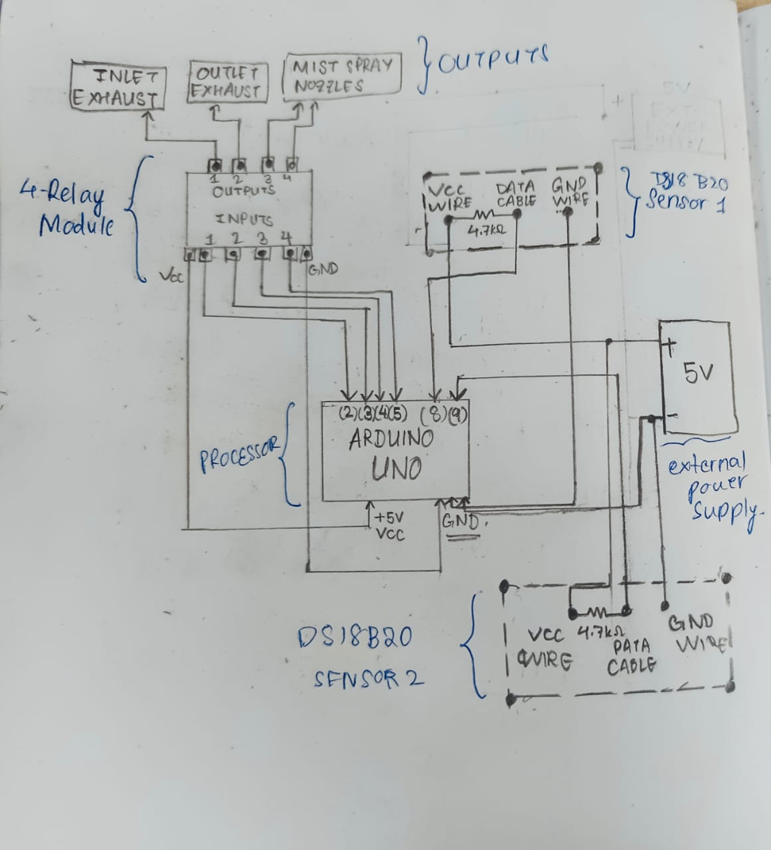

CHAPTER 5 – SOFTWARE SETUP:

**Required Libraries:**

Install via Arduino IDE Library Manager:

* **OneWire**
* **DallasTemperature**

**Arduino IDE Settings:**

* **Board**: Arduino UNO
* **Port**: Auto-detected
* **Baud Rate**: 9600

CHAPTER 6 – CODE OVERVIEW:

The following link re-directs you to the required source code for the project:

“ https://github.com/AtharvShyleshDave/Simple_Greenhouse_Project.git ”

CHAPTER 7 – OPERATING INSTRUCTIONS:

* Connect components as per circuit diagram.
* Upload the code to Arduino UNO using the IDE.
* Open Serial Monitor (9600 baud) to view temperature data.
* Observe relay activation if temp > 30°C.

CHAPTER 8 – SAFETY GUIDELINES:

* Never power high-voltage devices directly from the Arduino.
* Ensure relay module has an opto-isolator for safe switching.
* Handle all live wires and connections with proper insulation.
* Disconnect power when wiring changes are made.

**CHAPTER 9 – TROUBLESHOOTING :**

| **Issue** | **Cause** | **Solution** |
| --- | --- | --- |
| Serial monitor shows -127°C | Sensor not detected | Check sensor wiring and pull-up resistor |
| Relay doesn't activate | Logic pin mismatch | Confirm pin number and wiring |
| Arduino restarts | Overcurrent from relay | Use external power for the relay |